VM Creations

1.Go to search bar and type Virtual machines and select it

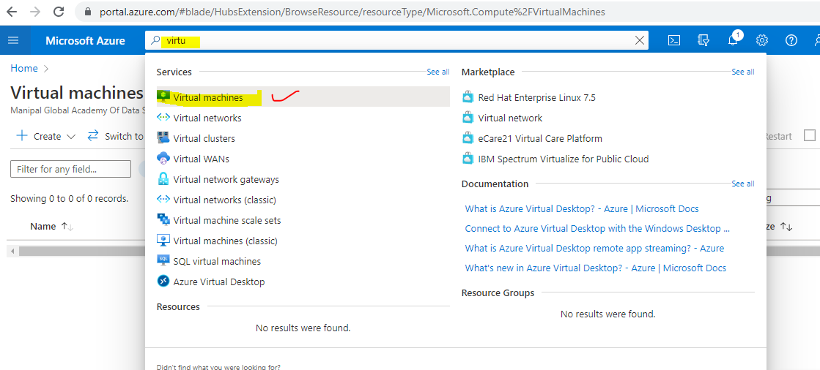

2.click on + create button and select Virtual machine

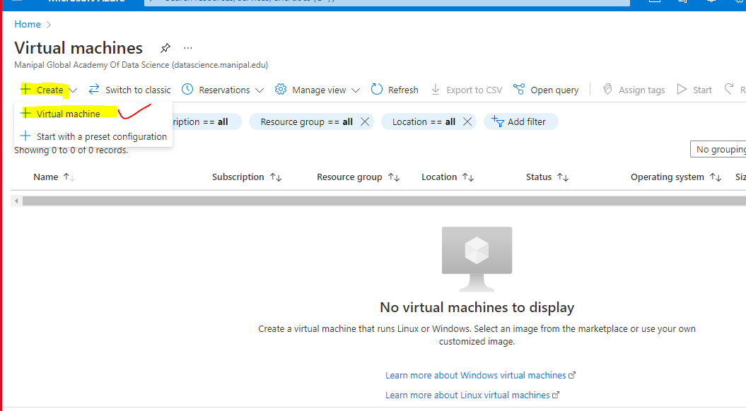

3.Create resource group and give vm name

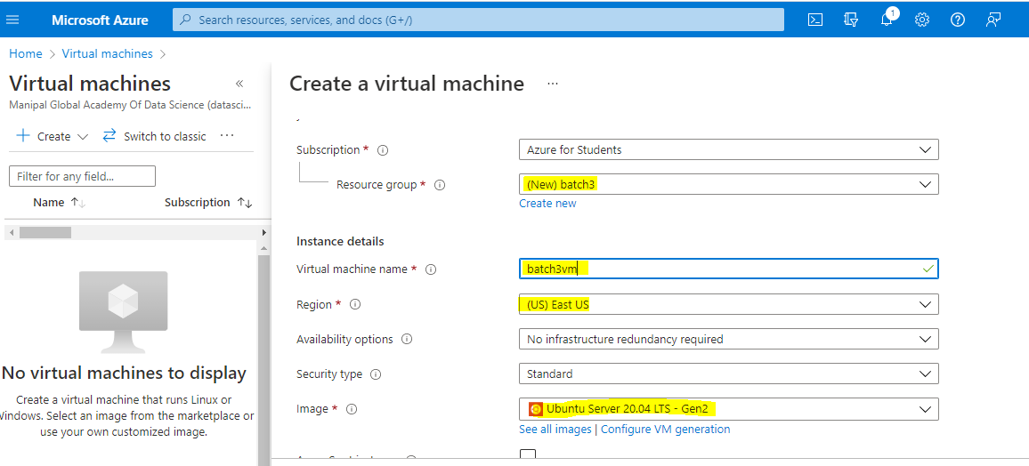

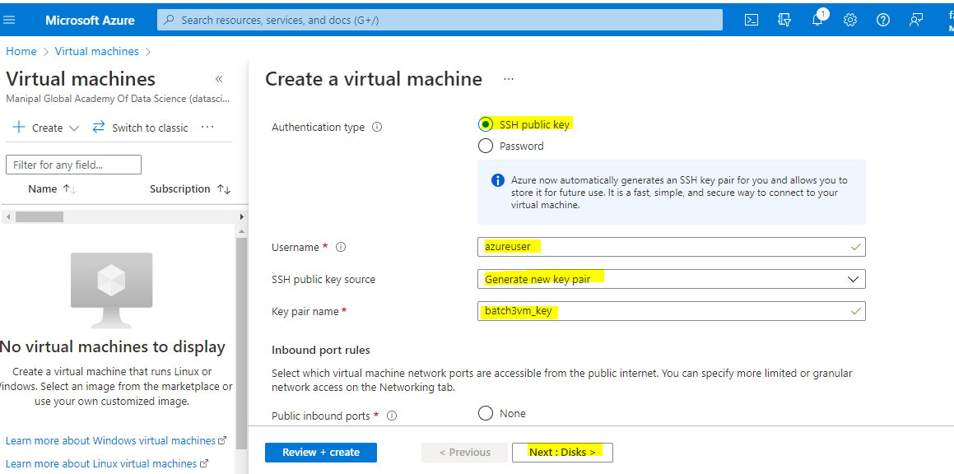

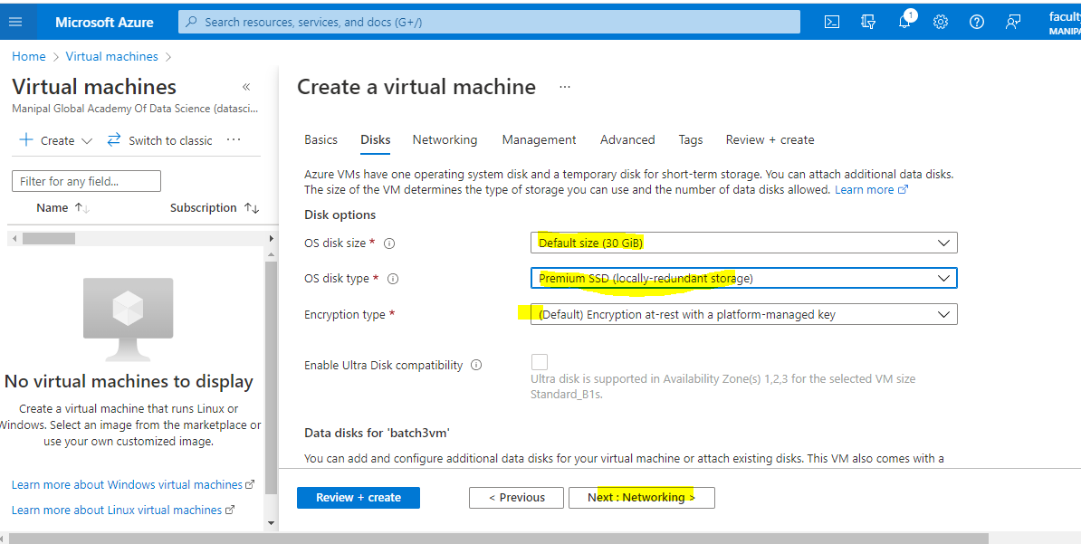

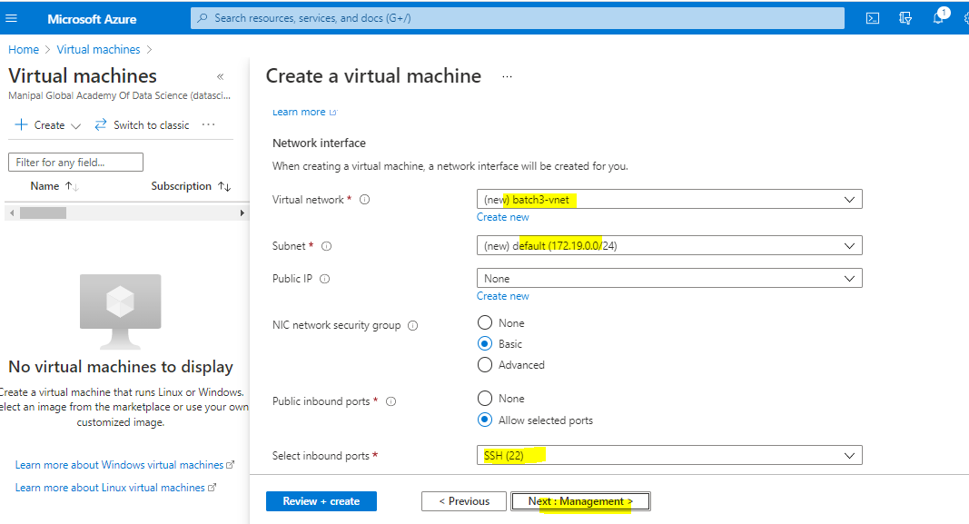

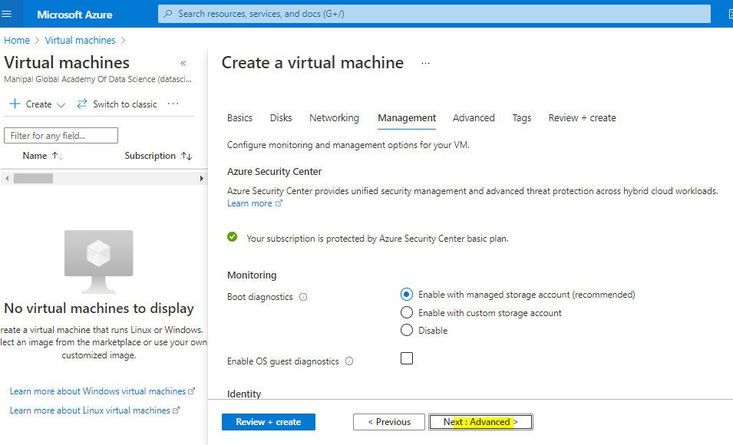

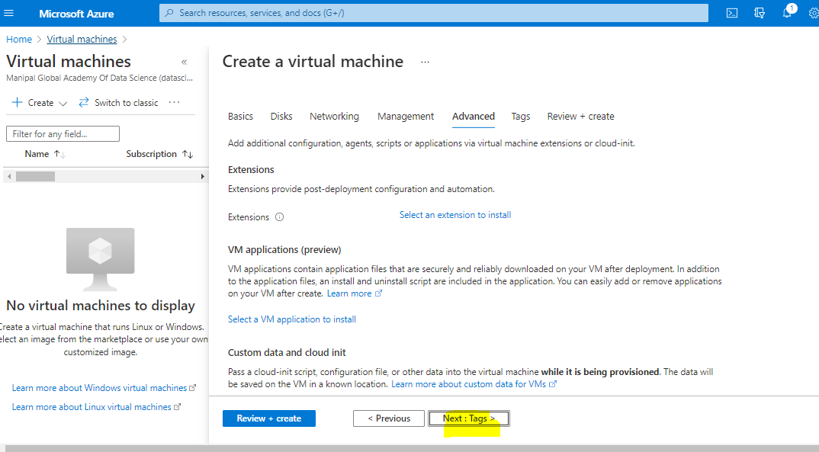

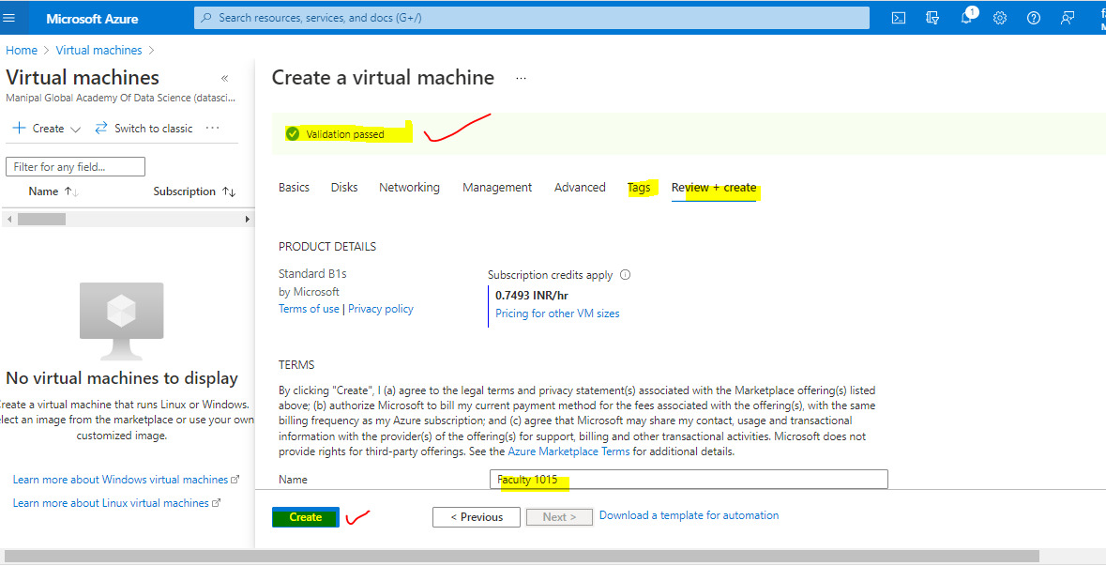

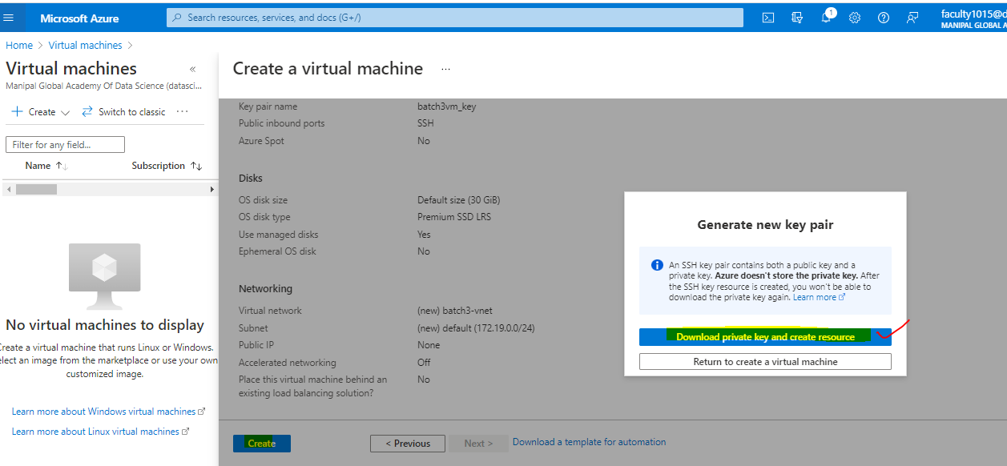

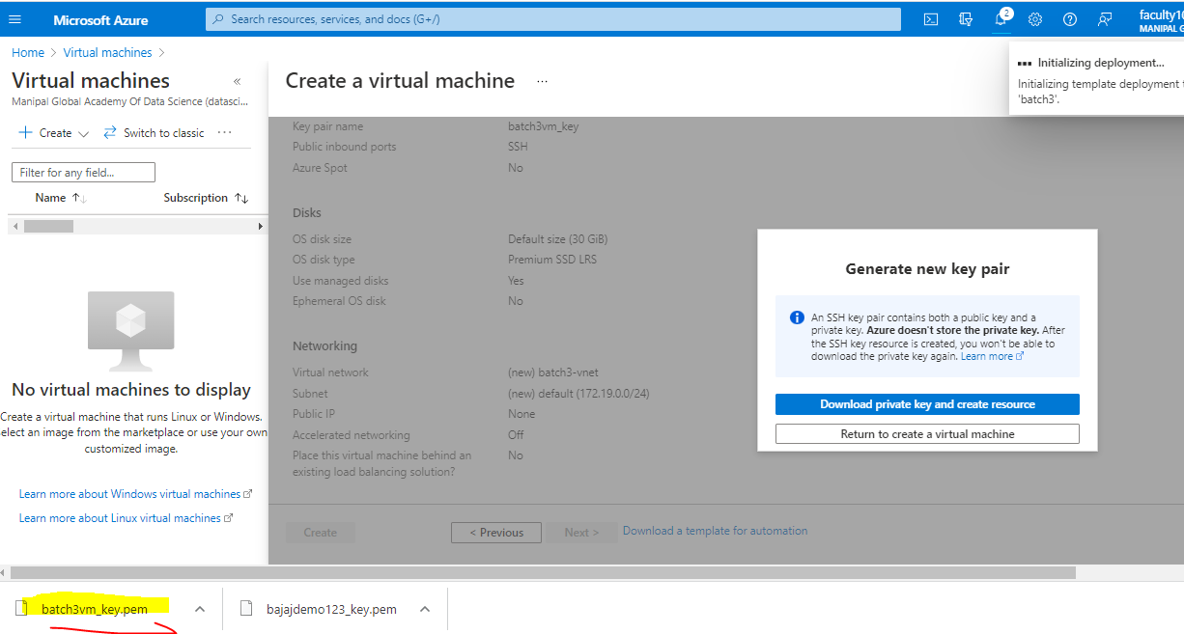

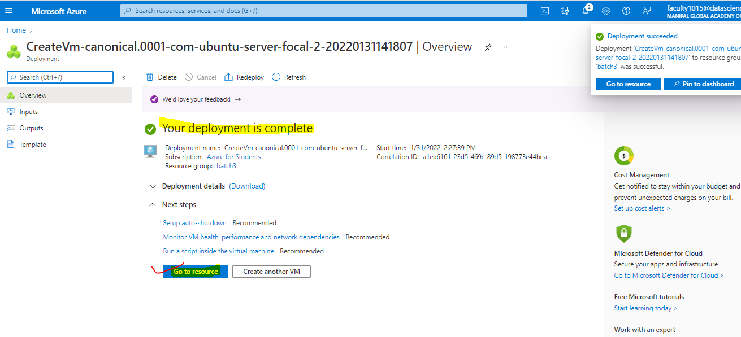

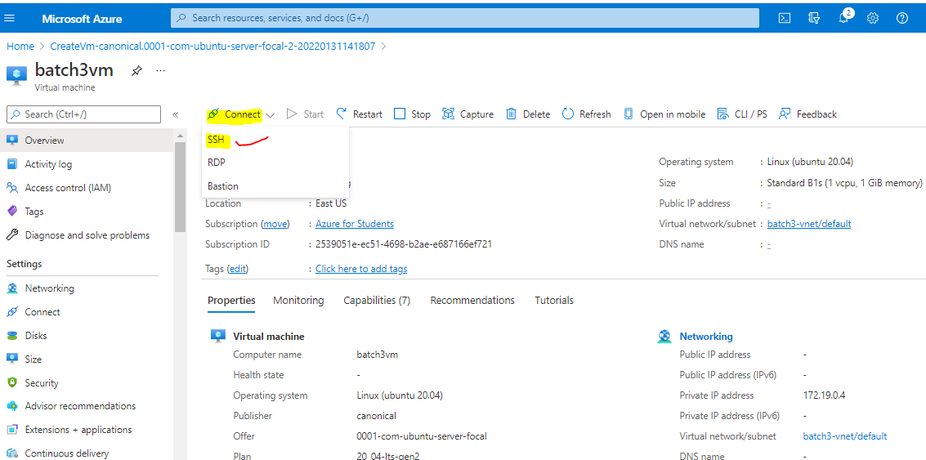

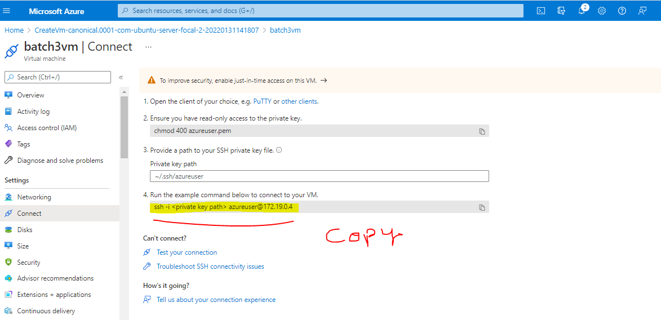

Before key path >>>>ssh -i <private key path> [azureuser@172.19.0.4](mailto:azureuser@172.19.0.4)

After key path>>>ssh -i C:\Users\Lenovo\Downloads\batch3vm_key.pem [azureuser@172.19.0.4](mailto:azureuser@172.19.0.4)

>>Open the cmd and change the directories into downloads

Command>>> cd downloads

>>paste the ssh key path

Command >>> ssh -i C:\Users\Lenovo\Downloads\batch3vm_key.pem [azureuser@172.19.0.4](mailto:azureuser@172.19.0.4)

After launch this ssh key path type Yes to continue

>>>update the virtual machine

Command>>>sudo apt-get update

>>>we can install the dockers in vm

Command>>sudo apt install docker.io

>>>to check the version of the docker we can launch below command

Command >>docker –version

>>>to create hello-world image we can using below command

Command>>sudo docker run hello-world

>>>to see how many images ae present in docker by use by below command

Command>>sudo docker images

>>>to see the list of process we can lounch below command

Command>>sudo docker ps -a